**Design Specification: B2B Relationship Measurement and Management System**



**Confidential:** The concepts, ideas, methodology and outputs are the property of ServiceQualityWorks, LLC, and are shared with the express understanding that 3rd parties will only use the information while working with ServiceQualityWorks, LLC.



**Table of Contents**

Overview 3

EMAIL MODULE 4

Soliciting Input 5

SURVEY MODULE 12

Survey Responses 13

DATABASE AND REPORTING MODULE 14

Intention to Do Business 15

# Overview

**Objective:**  To help companies better manage relationships

**Application/Use of System:**

1. Manage relationships between company and customers
2. Manage relationships between company and suppliers
3. Manage relationships between functional groups within the company

**Process:**

1. Email Invitation: Solicit information from both parties to relationship e.g. customer and front-line teams that service the customers
2. Web Survey: Collect information in structured format from both parties to relationship
3. Scorecards and Playbooks: Format information into easy to understand outputs (standardized data views linked to a specific dataset)
4. Custom Reporting: Allow stakeholders to generate custom data views based on specific needs
5. Trend Analysis: Allow companies to compare inputs over time (trends across data sets)

**Business Outcomes:** Companies use outputs – across the organization – to identify performance gaps and develop solutions to enhance relationships. Enhanced relationships lead to lower operating costs, increased revenues and profits.

EMAIL MODULE

Soliciting Input

**Objective:**  To solicit participation from relationship stakeholders, get targets to click embedded link to on-line survey

**Walk-Through:** The idea here is that a user will be able to upload lists of desired respondents e.g., their customers and front-line sales and account management staff that service the customers. Would be 2 separate lists (two different links) since survey for each group is slightly different.

The lists would include have to include first name and email address, but should also include additional data fields that could be combined with the data collected in the on-line survey

So user uploads CSV file with “First Name”, “Email” and additional data “Sales” “Product Type” etc….

The user then has to the option to send a series of pre- generated email messages to solicit input. The user has the ability to tweak the content of the messages e.g., change message title or message content

The message contains a unique link to online-survey (does not have to be unique but if we could identify each target e.g link http://survey link + unique specific user ID or a http://unique specific user ID

The user then hits button and sends email

Reporting functionality lets user know how many sends, how many bounces, how many opens, and how many clicks to online-survey.

Once someone had taken the survey the user must NOT be able to send another invitation to them.

**Requirements:**

1. Upload contact list and any additional respondent information, csv file
2. Review and create/ tweak email templates/ some sort of “library for email templates” that user can select from
3. Send email
4. Track sends, opens, bounces, clicks to survey, and survey completion
5. Send thank email to respondents who provided data

**Examples:** Tools currently used – GUI does not have to be the same, including as reference

**Management of groups**

Create new group

Group management - actions:

* Individuals in group

Group or “panel” members

Group or “panel”

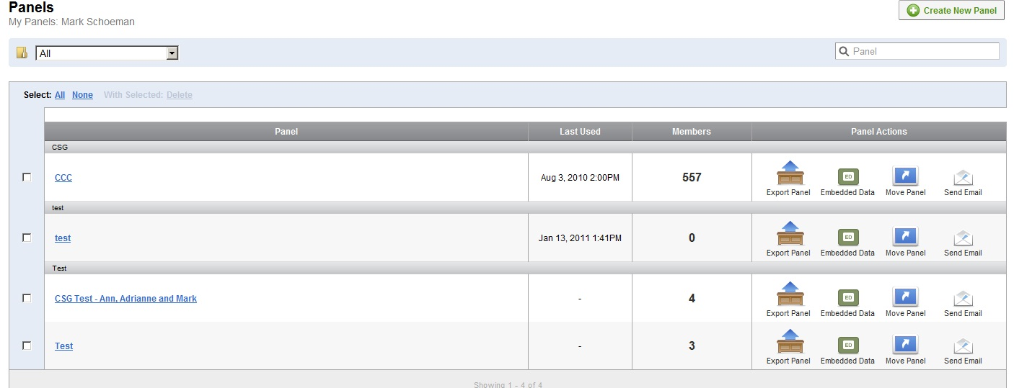

**Upload a group**

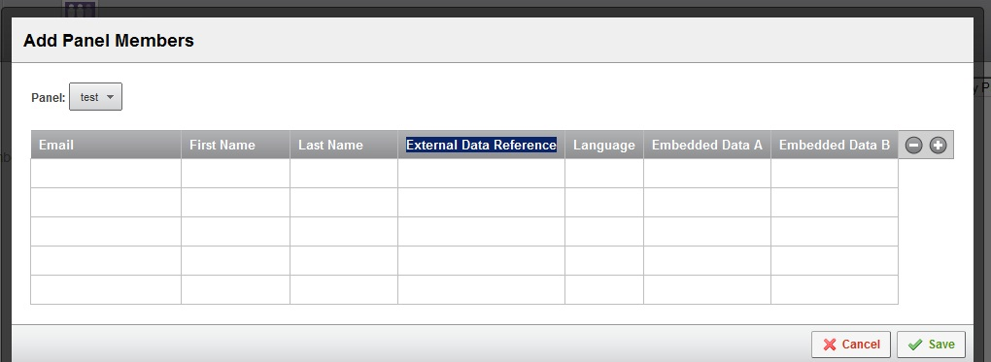

We also need a way of viewing contacts on an individual basis and editing if errors are made, could user click on contact and get a view of just that contact and then make updates

Must be able to create multiple recipient groups and delete groups – if required

Additional data fields specified by user, user can change data fields/ headings…. Or we just create 5 -10 standard fields and pre-name them

Must haves: Email address, first name, last name

Unique respondent link inserted

Graphic link inserted in email

**Example of email message**

Dear {~ML|FirstName~},

Recipient name drawn for data upload



My name is Peter Kalan, President and CEO of CSG Systems.

I want to thank you for your business with CSG. At CSG, we pride ourselves on being client focused and are committed to this value. To assist us, we are gathering feedback from our clients, and I want to personally invite you to take part in our ${l://SurveyLink?d=**2010 Client Engagement Initiative**}. To be more specific, I would like you to share with us what is important to you, how we perform, and how we can improve.

I recognize that building long-term strategic business partnerships starts, first and foremost, with being responsive to our clients. I am personally committed to acting on this information as we continue to improve our services and solutions. I would sincerely value your feedback.

We have prepared a brief on-line survey. The link below will take you directly to the questionnaire, which will take less than 10 minutes to complete:

${l://SurveyLink?d=**Survey Link**}   
  
or paste the following link into your browser:  
  
${l://SurveyURL}

Need built in html editor? Decide on how users can tweak standardized emails?

I look forward to sharing with you the findings of this initiative and our strategies for improvement in the coming year.  
  
Once again, thank you for input and your business.

Sincerely,

Peter

Peter Kalan  
President/CEO   
CSG Systems, Inc.  
[www.csgsystems.com](http://www.csgsystems.com/)  
**THE BUSINESS OF CUSTOMER INTERACTIONTM**

**Example of email set-up/ user selects email template/ user selects recipient group/ user specifies sender’s details**

User can choose which message template to use, assumption is that messages have been tweaked by user

User can specify details

User can select which contact group to send to

Unique survey link embedded in email

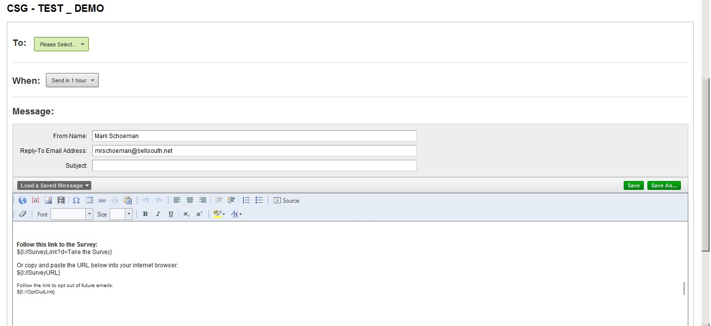

**Report from email sends**

Embedded link to survey highlighted

Good view of possible tabs

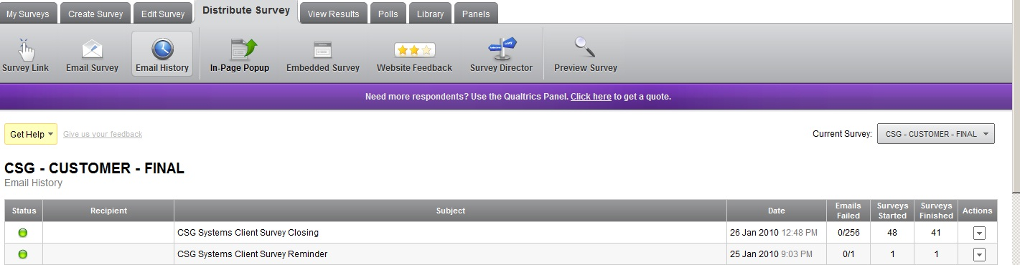

SURVEY MODULE

Survey Responses

Client Response

DATABASE AND REPORTING MODULE

Intention to Do Business